DS 522 Data Acquisition and Analytics
HOS06A-2 Power BI Installation

08/20/2022 Developed by Catherine Ata
05/06/2025 Reviewed by Naveena Moddu
10/21/2025 Reviewed by Ashwin Paturi
04/30/2026 Reviewed by Vishal Krishna Kumar

School of Technology & Computing (STC) @ City University of Seattle (CityU)



Before You Start
- Version numbers may not match the most current version at the time of writing. If given the option between a stable release (long-term support) and the most recent version, please select the stable release rather than the beta.
- This tutorial targets Windows users and macOS users.
- There might be subtle discrepancies along the steps. Please use your best judgment as you go through this cookbook-style tutorial to complete each step.
- Use your course number for your working directory. This tutorial may use a different course number as an example.
- The directory path shown in screenshots may be different from yours.
- If you are not sure what to do or are confused about any steps:
  - Consult the resources listed below.
  - If you cannot solve the problem after a few tries, ask a TA for help.

Key Concepts
- Power BI (Business Intelligence) Power BI is a powerful Data Visualization and Business Analytics tool provided by Microsoft. It helps us to provide interactive visualizations, dashboards, and BI reports with self-service capabilities. It is part of Microsoft Power Platform.
- Power BI Desktop is a free application you install on your local computer that lets you connect to, transform, and visualize your data. With a Power BI Desktop, you can connect to multiple data sources and combine them (often called modeling) into a data model. This data model lets you build visuals and collections of visuals you can share as reports with other people inside your organization. Most users working on business intelligence projects use Power BI Desktop to create reports and then share them in the Power BI service.

Learning Outcomes
- Download and install Power BI Desktop
- Power BI Configuration

STEP 1: Download and install Power BI Desktop: Please go to this link: Download Power BI | Microsoft Power Platform.
If the above link does not work, use this link: Download Microsoft Power BI Desktop from Official Microsoft Download Center.
Click the download button.
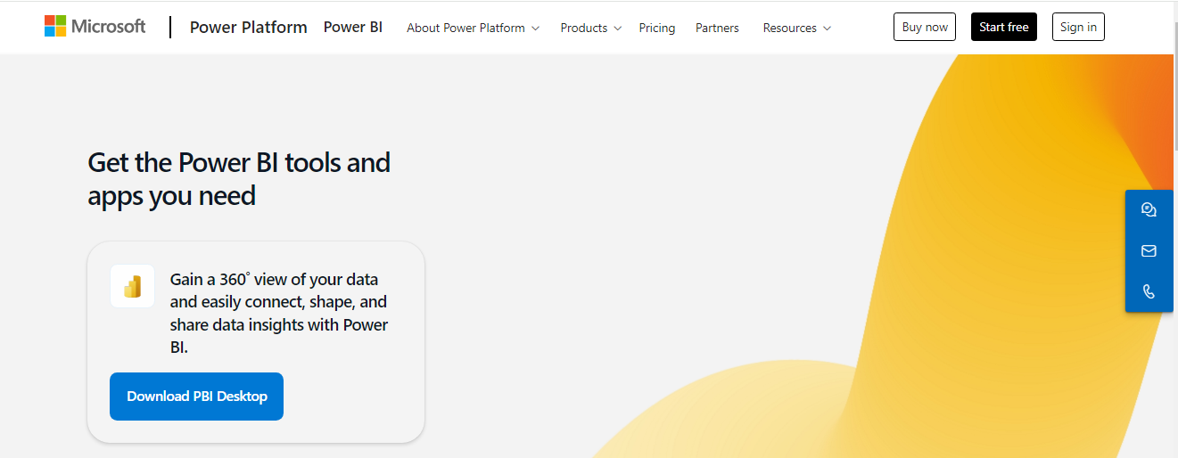
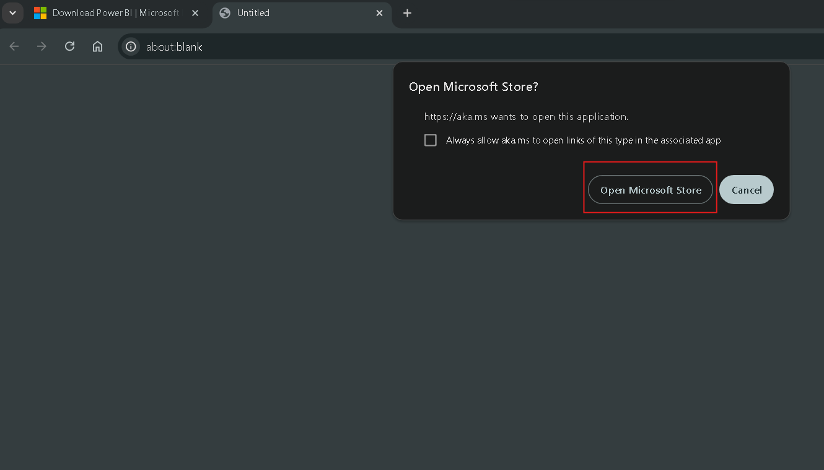
If you are using Windows, a pop-up will prompt you to open the Microsoft Store. Please do so.

This will take you to the Power BI Desktop App Install window in the Microsoft Store. Click Install.
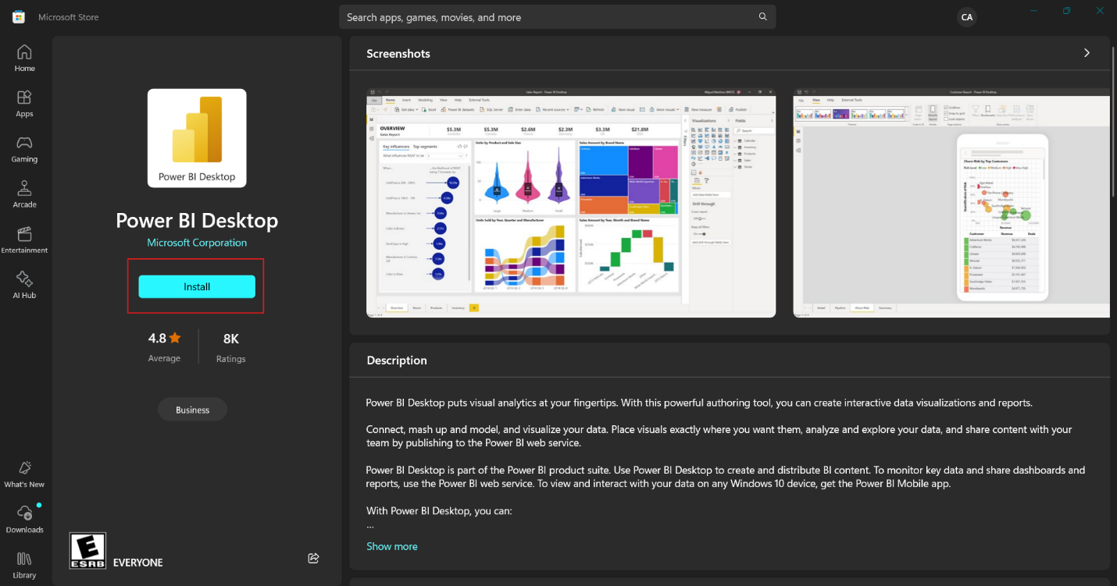
For Mac OS, you can either use the web version of Power BI or access it through Microsoft Teams.
This will take you a few minutes to download.
Once done, open the desktop application. Sign in using your CityU account to make sure you can access all necessary features of Power BI. Then continue.
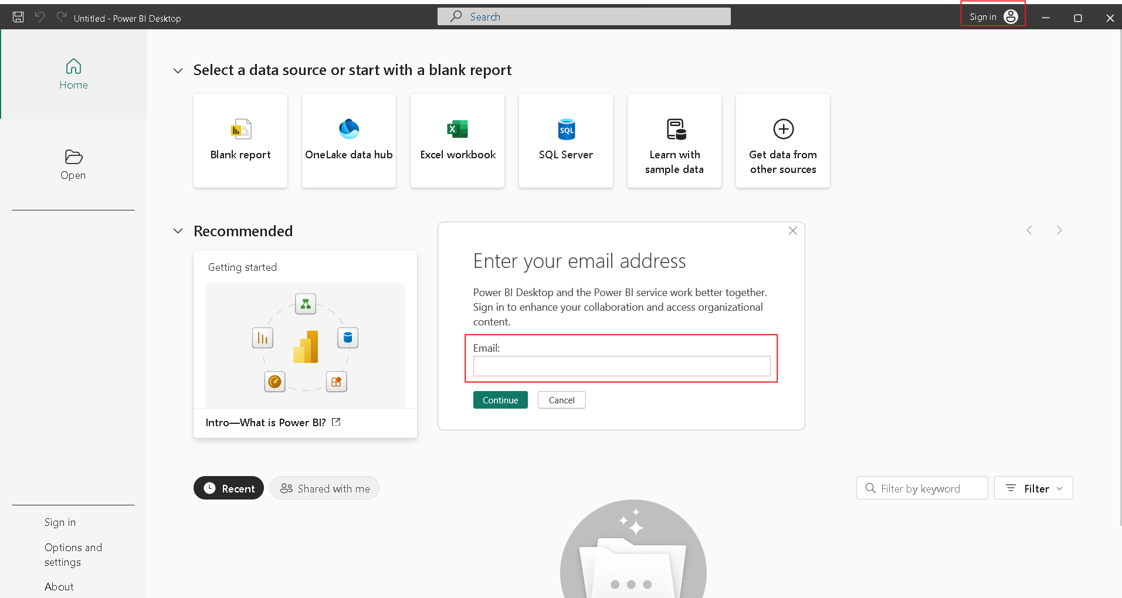
It will take you to the Power BI Dashboard that looks like the figure below:
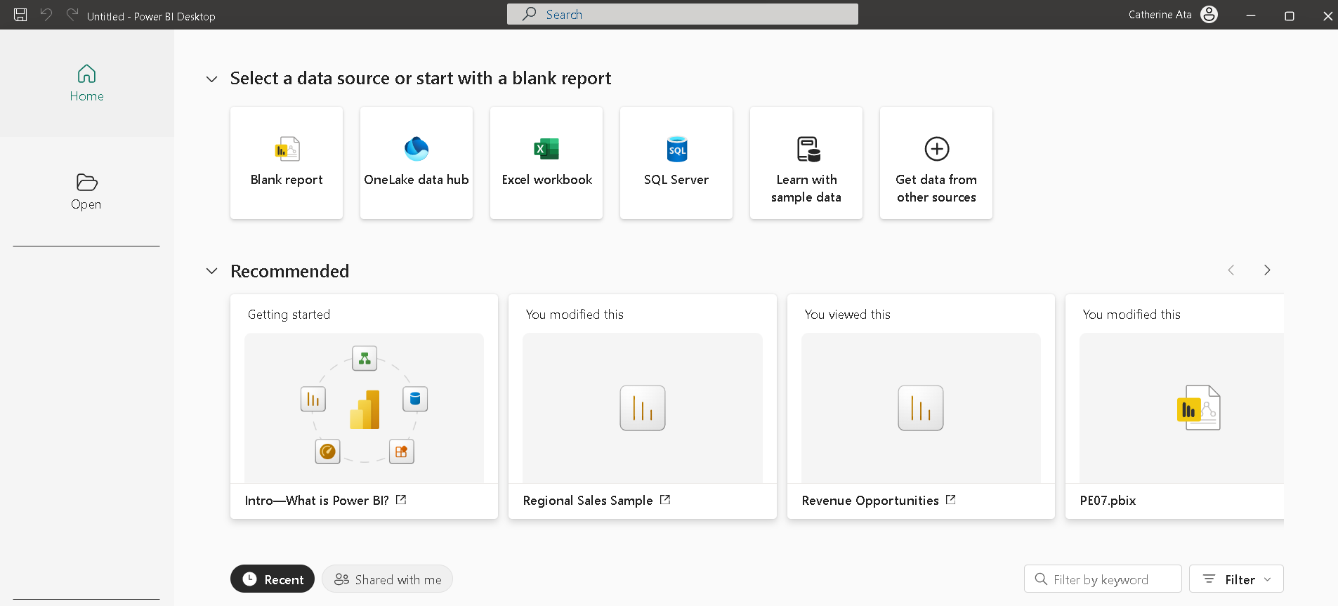
Please take a screenshot of this and upload it to the GitHub repo to prove your installation is successful. (NOTE: If you already have Power BI Desktop, please take a screenshot of the main page of your Power BI Desktop.)
Step 2: Configure Power BI Desktop to Show all Features.
Click Options and settings on the lower left navigation bar.

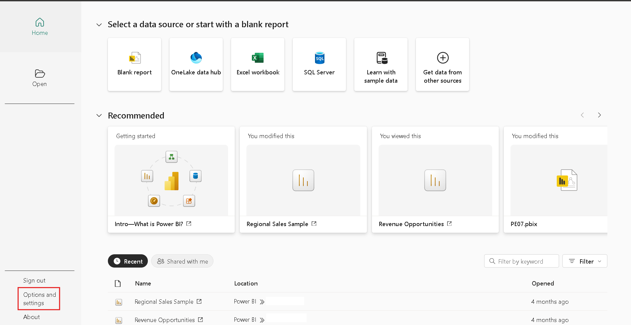

In the Options and settings page, click Options.
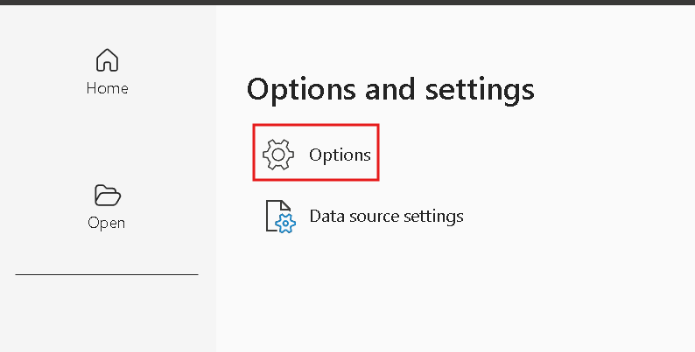
This will open the Options window, then click Preview features.
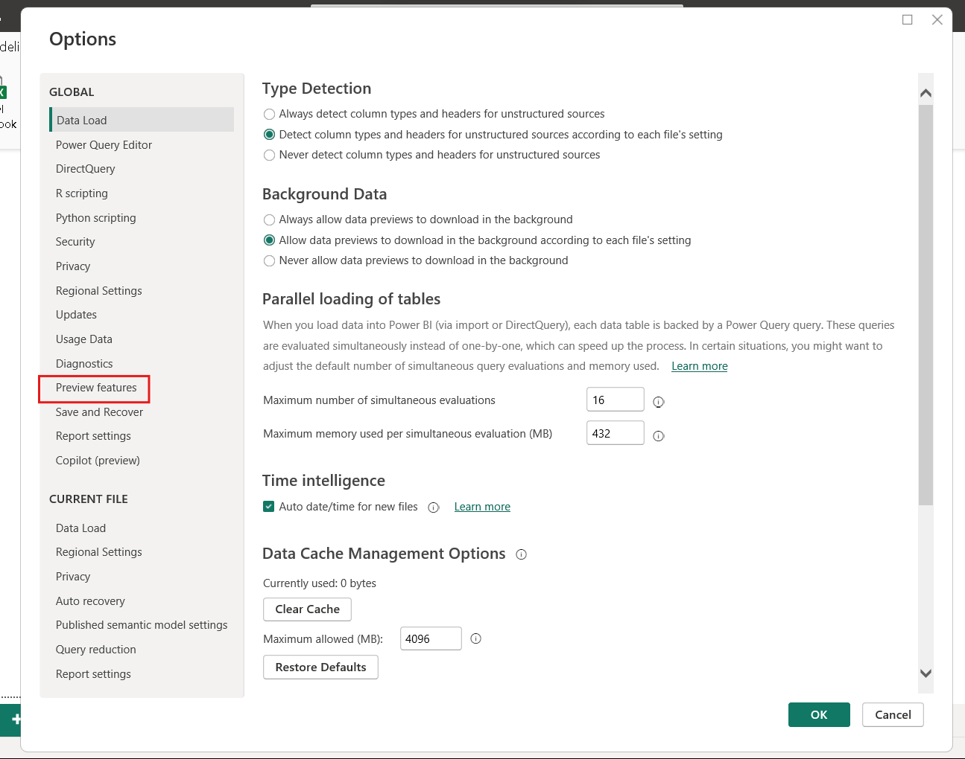

Tick all the options provided, then click OK.
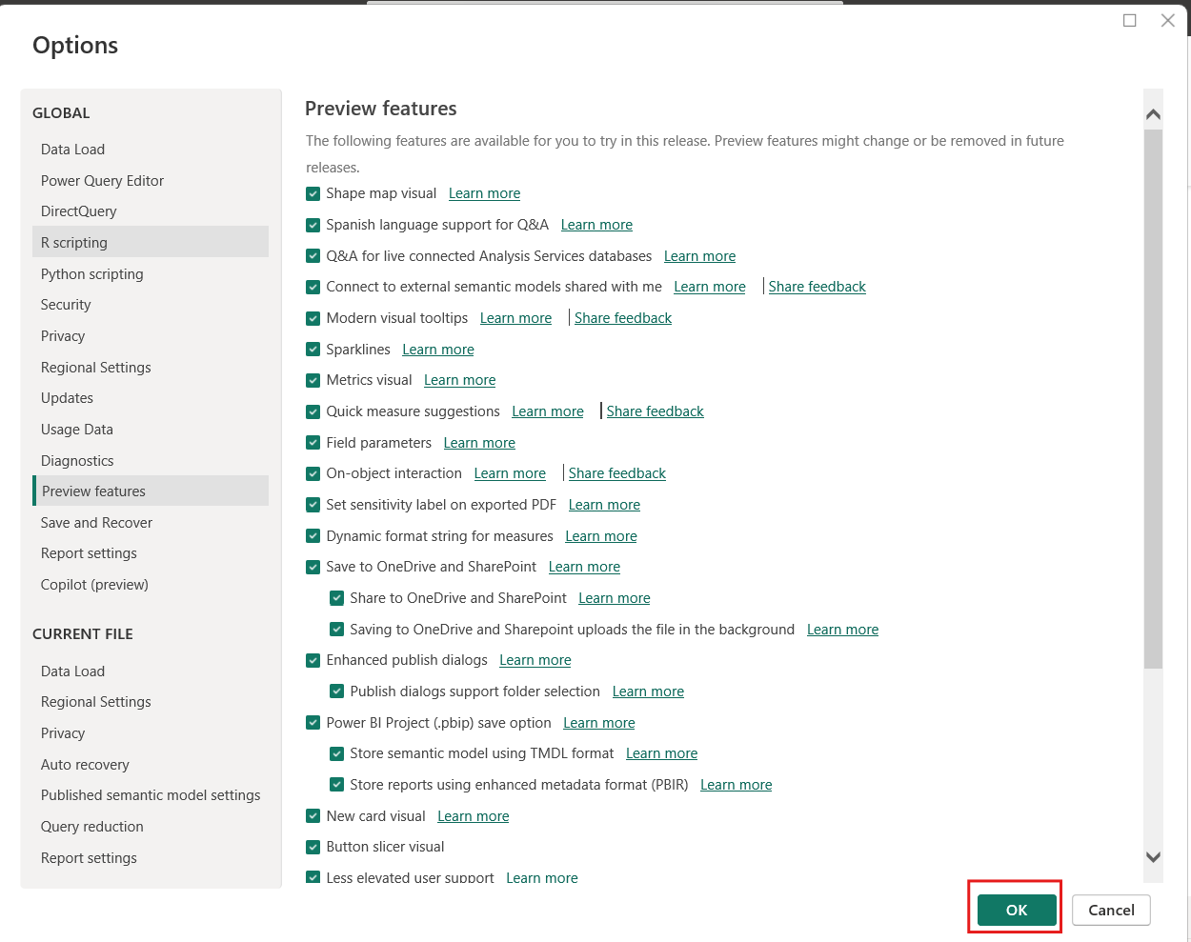
Push your work to GitHub:
- Include your screenshots stored in this file: HOS06A -2- Name_Submission.pdf.
- Follow the instructions on the CityU STC TA Center Github.io Submit your work page.

